Name ______________________ Student ID ___________________

Algorithms -- SOLUTIONS

Midterm , June, 2009
(10 points per problem)

1. Definitions. To give the definitions of the italicized terms below, complete the sentence provided.

A. A sorting algorithm is inversion-bound if for any input array arr of size n…

the algorithm performs at least as many comparisons as the number of inversions
in arr

- A function f(n) is said to belong to O(g(n)) if…

there exist positive constants c, n₀ such that f(n) ≤ cg(n) for all n ≥ n₀

- A sorting algorithm is stable if, whenever
[(k₀, d₀), (k₁,d₁), …, (k_{i},d_{i}),…,(k_{j},d_{j}),…,(k_{n},d_{n})]
is an input sequence of objects to be sorted by the keys k₀, k₁,… k_{n}, and k_{i} = k_{j} and
i < j, then …

(k_{i},d_{i}) occurs before (k_{j},d_{j}) in the final output sequence

2. Use the QuickSelect algorithm to manually compute the 4th smallest
element of the array [1, 5, 23, 0, 8, 4]. Assume that the rightmost element is used as the pivot in each case. Show what happens in each self-call, indicating the new input array and the current value of k.

QS (1, 5, 23, 0, 8, 4), k = 4

L = [1,0], E = [4], G = [5, 23, 8]
k' = k - |L| - |E| = 4 – 3 = 1

QS (5, 23, 8) , k = 1

L = [5], E = [8], G = [23]
k' = k = 1

QS (5), k = 1

L = [ ], E = [5], G = [ ]

|L| < k ≤ |L| + |E|, so return 5

3. Do just ONE of the following (if you do both problems, you will get no credit for either of the problems).
a. Use the definition of big-oh to show that
n²+n is not O(n)

Given positive constants c, n₀, we find n ≥ n₀ for which n²+n > cn.

Pick n so that n > c, n₀, 1. Since c < n, n*c < n² and so we have

cn < n² < n²+n
b. Use limits to prove the following:
(log n)² is O(n)

lim_{n} (log n)²/n = lim_{n} (2c₀ log n)/n (by L’Hopital)

= lim_{n} 2c₀((log n)/n)

= 2c₀ lim_{n} c₁/n

= 0

4. Use the Master Formula to compute T(n) explicitly, assuming it satisfies the following recurrence relation:
T(1) = d (d > 0)
T(n) = 10T(n/3) + 2n²

Using the Master Formula, we see that

a = 10, b = 3, c = 2, k = 2, and a > b^{k}

Therefore

T(n) is Θ(n^{x}), where x = log₃ 10

Since log₃ 10 > 2, it follows that

T(n) belongs to Ω(n²).

5. Write out the PowerSet Algorithm in pseudo code.
Algorithm: PowerSet(X)
Input: A list X of elements
Output: A list P consisting of all subsets of X – elements of P are Sets
P ← new list
S ← new Set //S is the empty set
P.add(S) //P is now the set { S }
if X.isEmpty then
return P
else
while (!X.isEmpty() ) do
f ← X.removeFirst()
for each x in P do
S ← x U {f} // S is the set containing f & all elements of x
P.add(S)
return P

6. The following function computes, for any positive input integer n, the number of positive integers ≤ n that are relatively prime to n. What is the asymptotic running time of this function, as a function of input values? What is the asymptotic running time as a function of input size? Hint: If the running time as a function of input values is O(f(n), then the running time as a function of input size is O(2^{f(length(n))}).

public static int eulerPhi(int n) {
if(n < 1) return -1;
int numRelPrime = 0;
for(int d = 1; d <= n; ++d) {
if(gcd(d,n) == 1) ++numRelPrime;
}
return numRelPrime;
}

private static int gcd(int m, int n) {
if(n == 0) return m;
return gcd(n, m%n);
}

Relative to input values:
gcd performs in O(log n)
eulerPhi performs in O(nlog n)

Relative to input size:
gcd performs in O(length(n))
eulerPhi performs in O(length(n)*2^{length(n)}))

7. A flexible table is a kind of data structure storing Strings that uses an array in the background (assume it is already initialized and has as many available slots as necessary without resizing) and that has three primary operations:
- AddOne(x) – adds String x to the background array in the next available slot
- AddTwo(x,y) – adds Strings x and y to the background array by placing them in the next two available slots.
- ClearAll() – removes all Strings currently in the array by setting them to null.
Show that the amortized running time of ClearAll is O(1). Do the steps required by filling in the following table. Hint: For your amortized cost function, try charging 2 cyberdollars for AddOne, 4 cyberdollars for AddTwo and 0 cyberdollars for ClearAll.
Your cost function c:
c(AddOne) = 1
c(AddTwo) = 2
c(ClearAll) = k, where k is number of non-null Strings in the
array

Your amortized cost function ĉ:

ĉ(AddOne) = 2
ĉ(AddTwo) = 4
ĉ(ClearAll) = 0

How do you know that your amortized cost function never results in negative amortized profit:

The array obtains values via the operations AddOne and AddTwo. Whenever AddOne is invoked, $1 profit is stored. Likewise, whenever AddTwo is invoked, $2 profit is stored. In each case, $1 profit is stored for each element added. Therefore, whenever ClearAll is invoked when there are k elements in the table, $k profit is available to pay for ClearAll, and this is exactly enough to pay for the ClearAll operation.

Provide a bound for the amortized cost of running n of these operations in succession.

Since profit is always nonnegative,

Σ_{1≤i ≤n}c(s_{i}) ≤ Σ_{1≤i ≤n} ĉ(s_{i}) ≤ Σ_{1≤i ≤n} 4 = 4n

Explain why ClearAll has amortized running time O(1):

ClearAll has amortized running time O(4n)/n since amortized running time of all n operations executed in sequence is O(4n). Therefore ClearAll has amortized running time O(1)

8. The following algorithm computes the difference between the minimum and maximum values of an input array. Compute the total number of primitive operations used in the worst case.

Algorithm arrayRange(A, n)
Input array A of n integers
Output difference between max and min values of A
currentMax ← A[0]
+2
currentMin ← A[0] +2
for i ← 1 to n - 1 do +n + 1
if A[i] > currentMax then +2(n-1)
currentMax ← A[i] +2(n-1) (one or other)
if A[i] < currentMin then +2(n-1)
currentMin ← A[i]
{ i ← i + 1 } +2(n-1)
return currentMax - currentMin +2
__________

9n – 1
Note: This calc doesn’t count repeated computation of n-1 in for loop.
Doing so would lead to an additional n operations, producing a total of

10n – 1

9. Work through the steps of MergeSort (implementation version) on the input array [1,4,7,2,3,4,1]. Show all steps.

Array length = 7, so length – 1 = 6

ms(temp, 0, 6)
mid = 3
ms(temp,0,3)
mid =1
ms(temp, 0, 1)
mid = 0
ms(temp, 0, 0)
return
ms(temp, 1, 1)
return
merge(temp, 0,1,1) //state: [1][4] → [1,4]
//array: [1,4,7,2,3,4,1]
ms(temp,2,3)
mid = 2
ms(temp, 2, 2)
return
ms(temp, 3, 3)
return
merge(temp, 0, 3, 3) //state: [7][2] → [2,7]
//array: [1,4,2,7,3,4,1]
merge(temp,0,2,3) //state: [1,4],[2,7] → [1,2,4,7]
//array: [1,2,4,7,3,4,1]
ms(temp,4,6)
mid=5
ms(temp,4,5)
mid = 4
ms(temp, 4, 4)
return
ms(temp, 5, 5)
return
merge(temp,4,5,5) //state: [3], [4] → [3,4]
//array: [1,2,4,7,3,4,1]
ms(temp,6,6)
return
merge(temp,4,6,6) //state: [3,4][1] → [1,3,4]
//array: [1,4,7,2,1,3,4]
merge(0,2,6) //state: [1,2,4,7], [1,3,4] → [1,1, 2, 3, 4, 4, 7]

10. Give a high-level proof of just one of the following theorems that we
proved in class:

Theorem 1. Every comparison based sorting algorithm has, for each n, running on input of size n, a worst case in which its running time is Ω(nlog n).
Theorem 2. The average case running time of QuickSort is O(nlog n).
Theorem 3. The running time of GCD(m,n) in terms of its input values m, n is
O(log n). In terms of its input sizes, its running time is O(length(n)).

The statement of the Theorem you are going to prove:

The high-level proof of the theorem you wrote in the previous box:

11. SCI Extra Credit Essay Question (3 points). Elaborate upon a parallel between points and topics in Algorithms and one or more SCI principles.
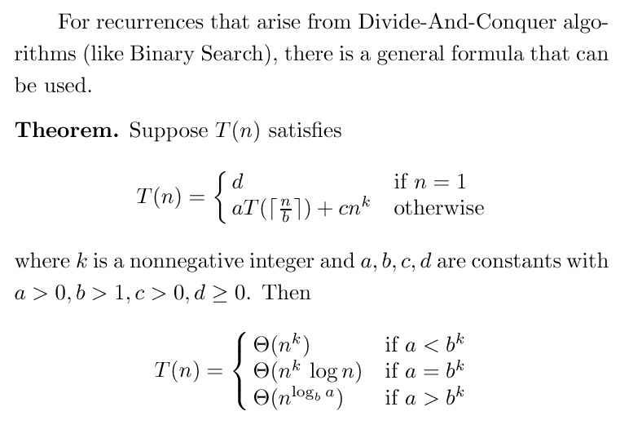
The Master Formula

